***19L245-SENDHILNATHAN E***

***IBM EEC: ASSIGNMENT-1***

***21/9/22***

***1.MARKETING SPENDS VS R&D IN BAR GRAPH AND HIERARCHY CIRCLE:***

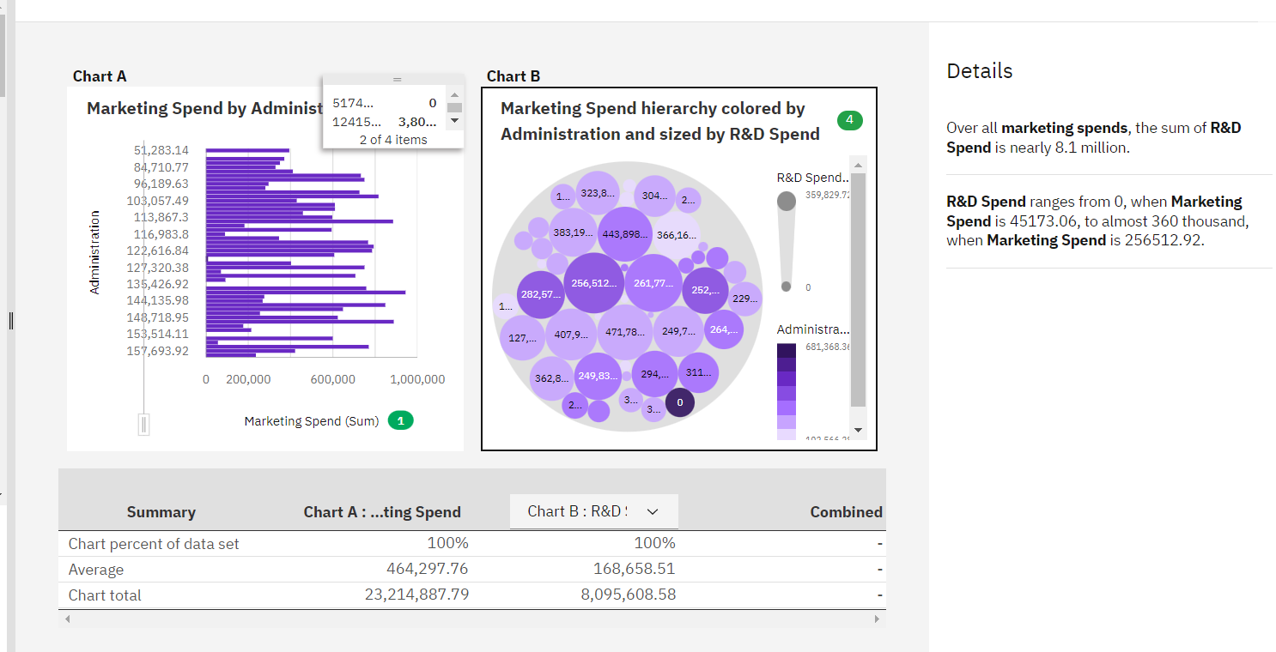

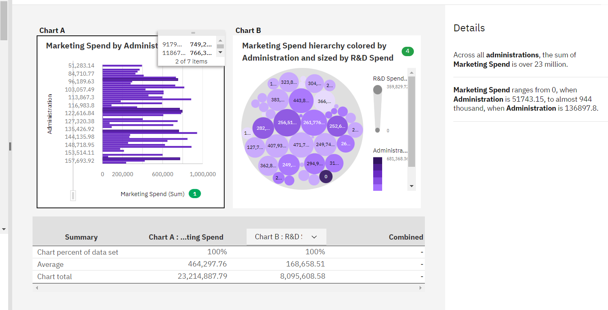

***2.PROFIT VS R&D AND MARKETING SPEND VS ADMINISTRATION:***

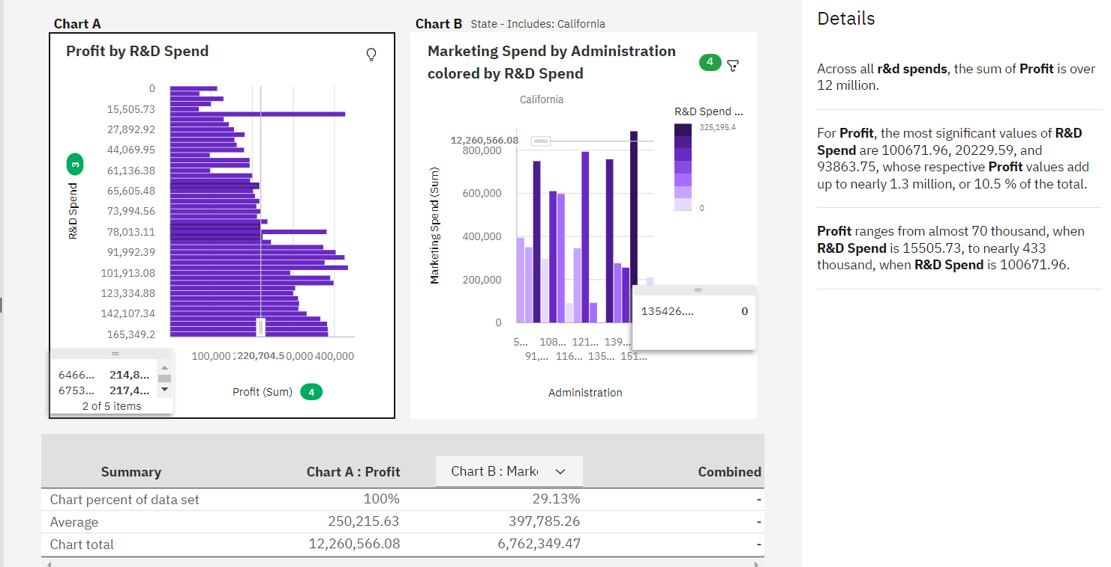

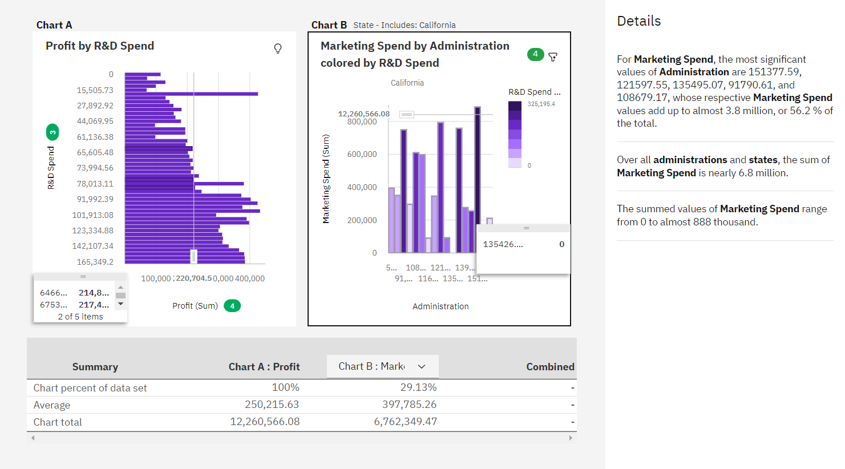

***3.REGIONAL MAP OF SPENDING ANALYSIS:***

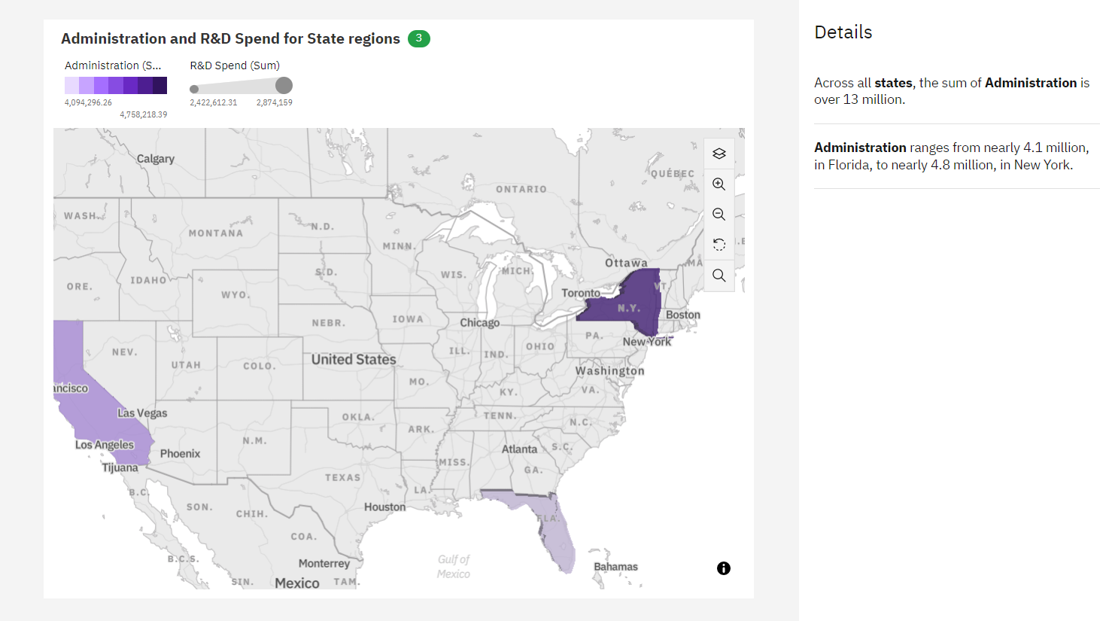

***4.R&D IN SPIRAL***

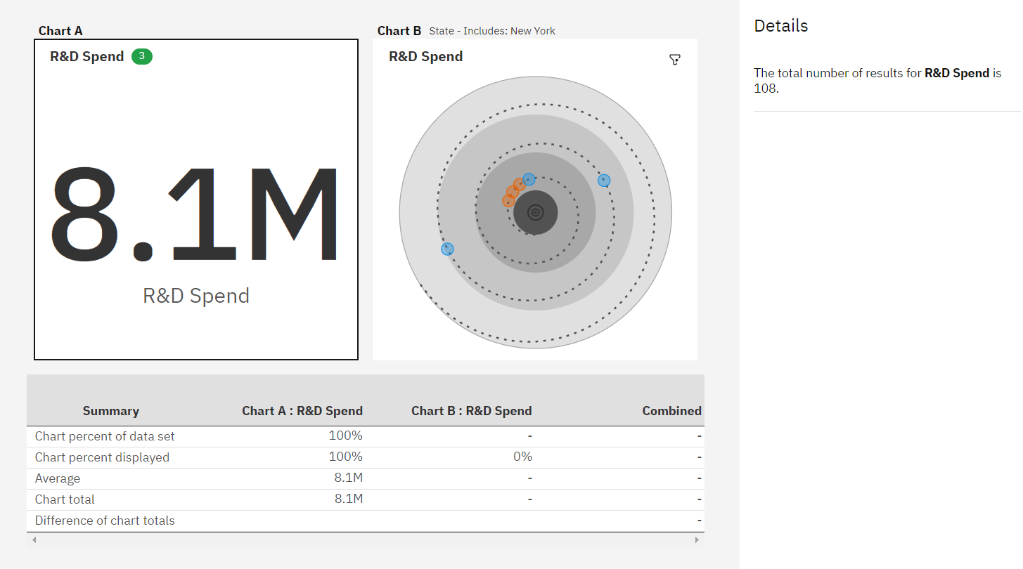

***5.PROFIT VS R&D:***

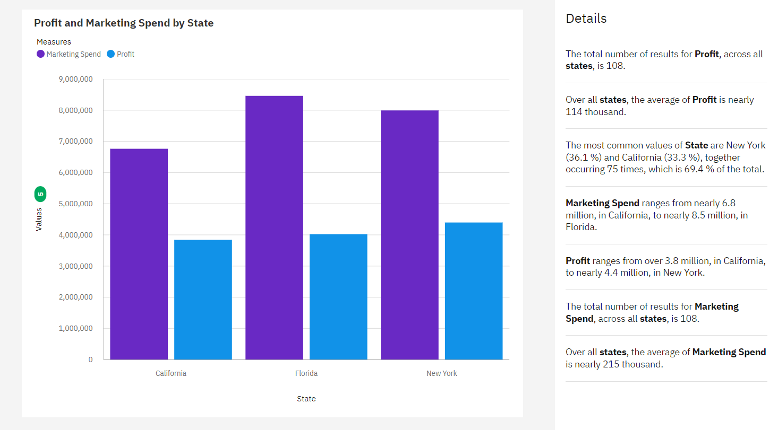

**6**.***PROFIT VS MARKETING SPENDING***

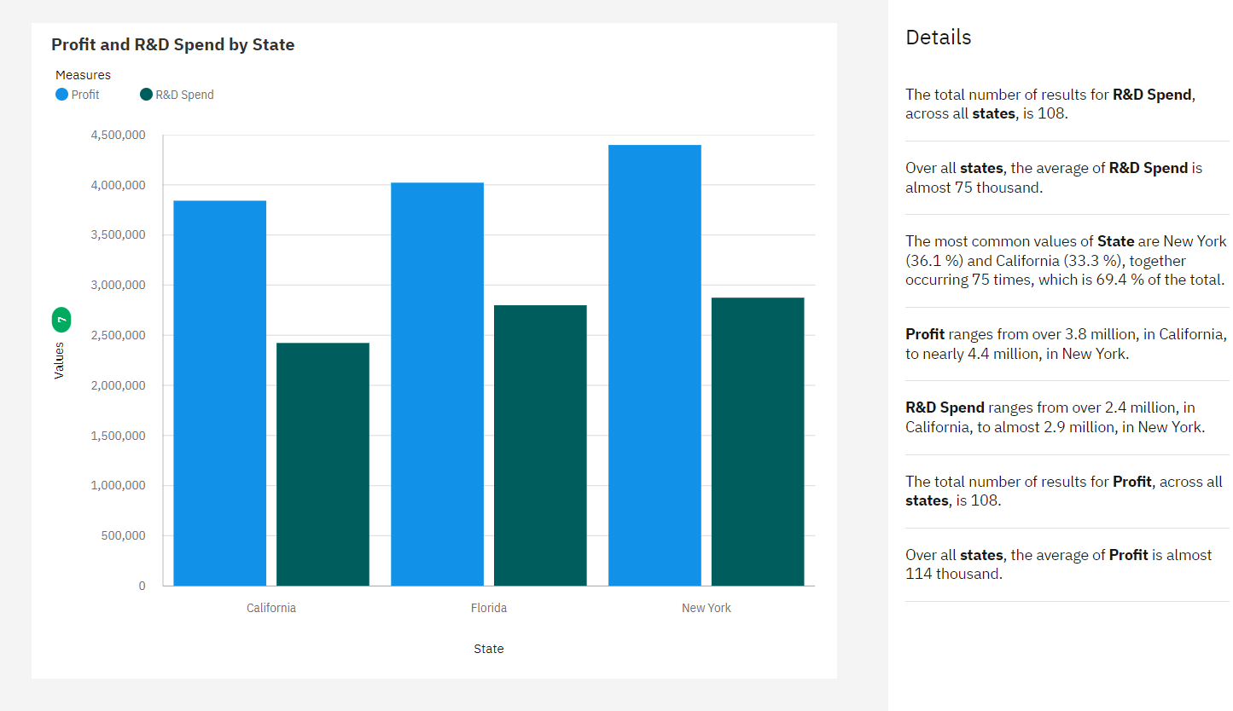

***7.R&D ADMINISTRATION AND MARKETING IN PIE CHART:***

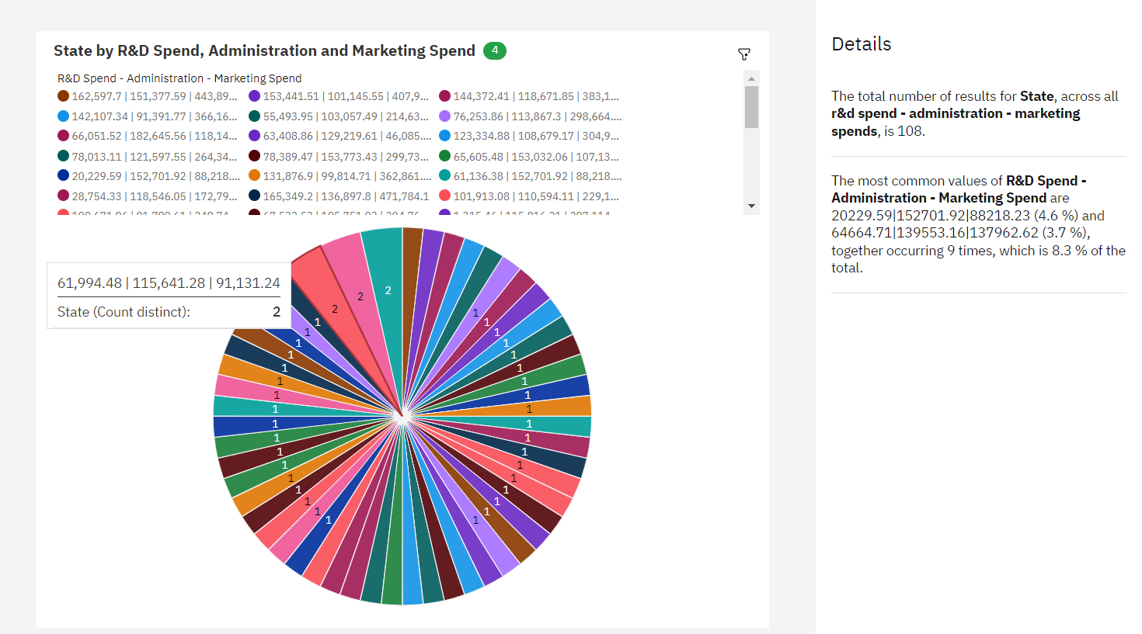

***8.R&D SPEND VS PROFIT IN CROSS BAR:***

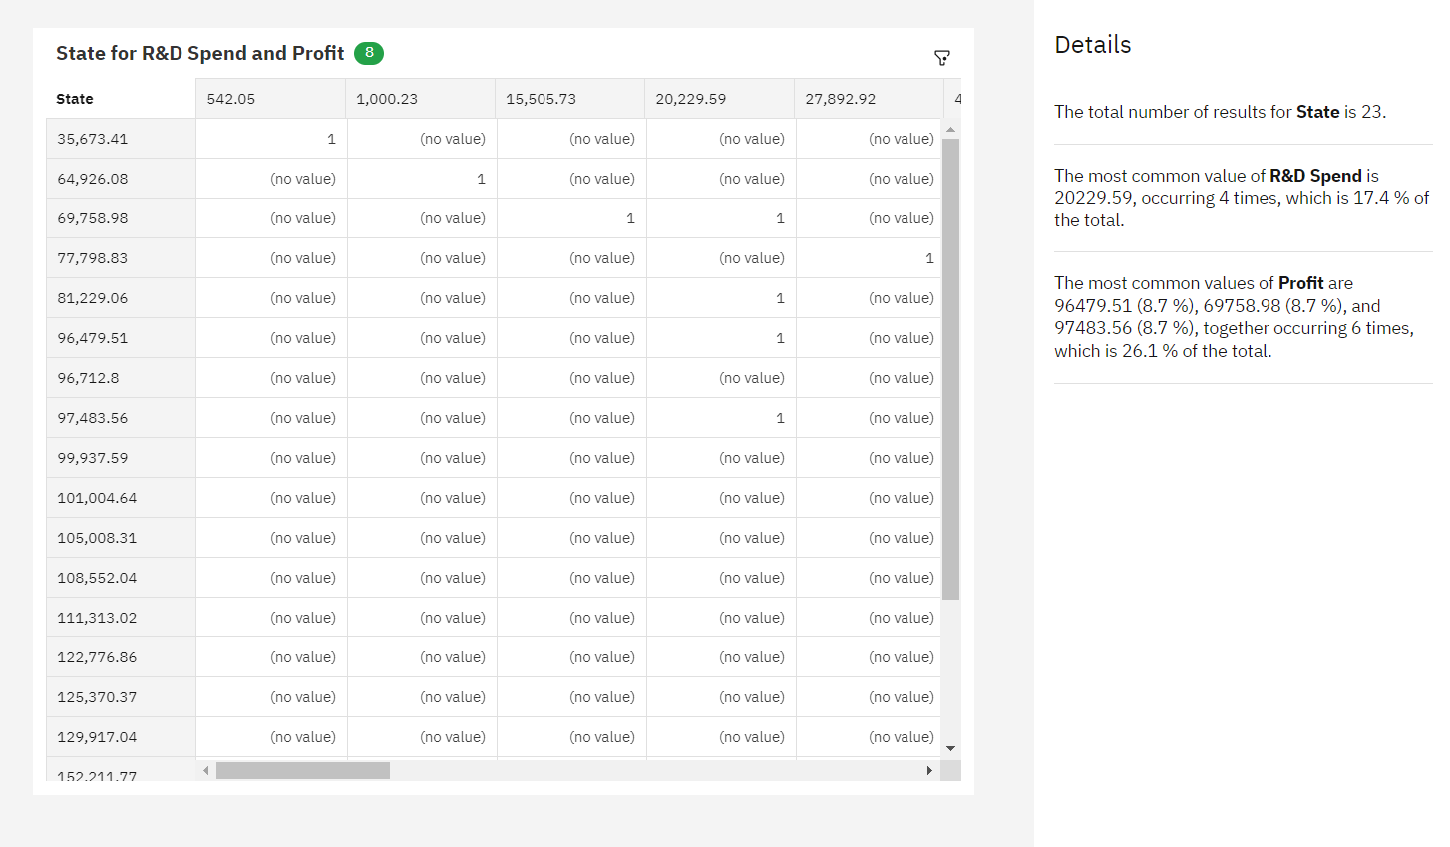

***9.R&D SPEND IN SUNBURST:***

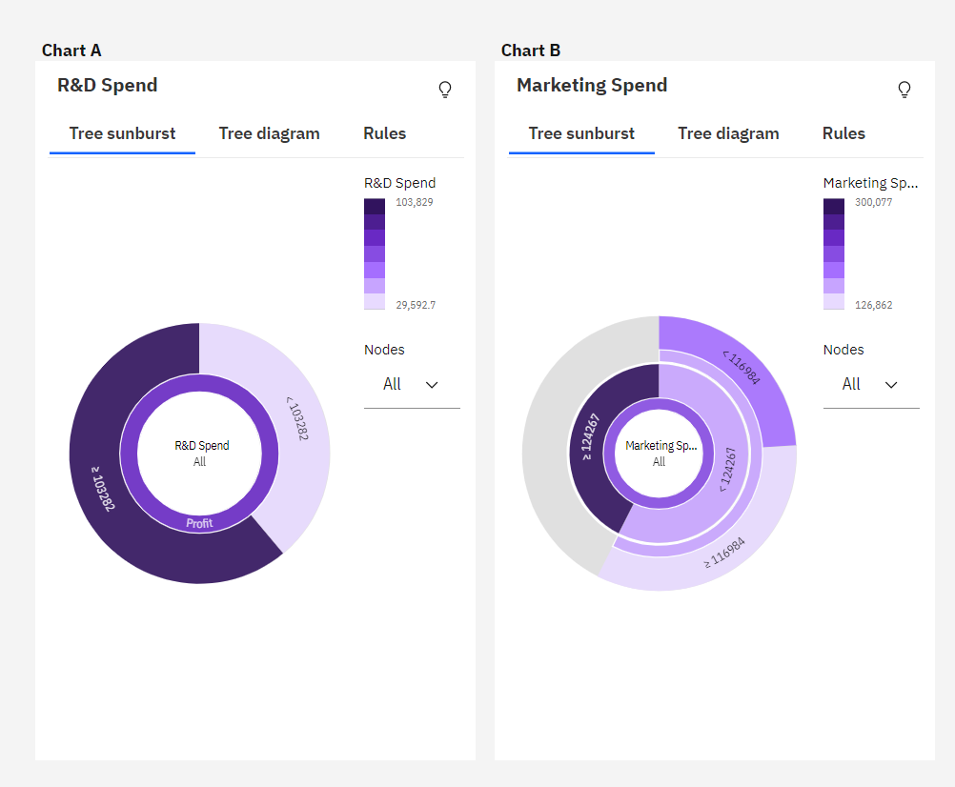

**10.DECIDING WHETHER PROFIT TO R&D ON INCREASING SIDE OR VICE VERSA:**

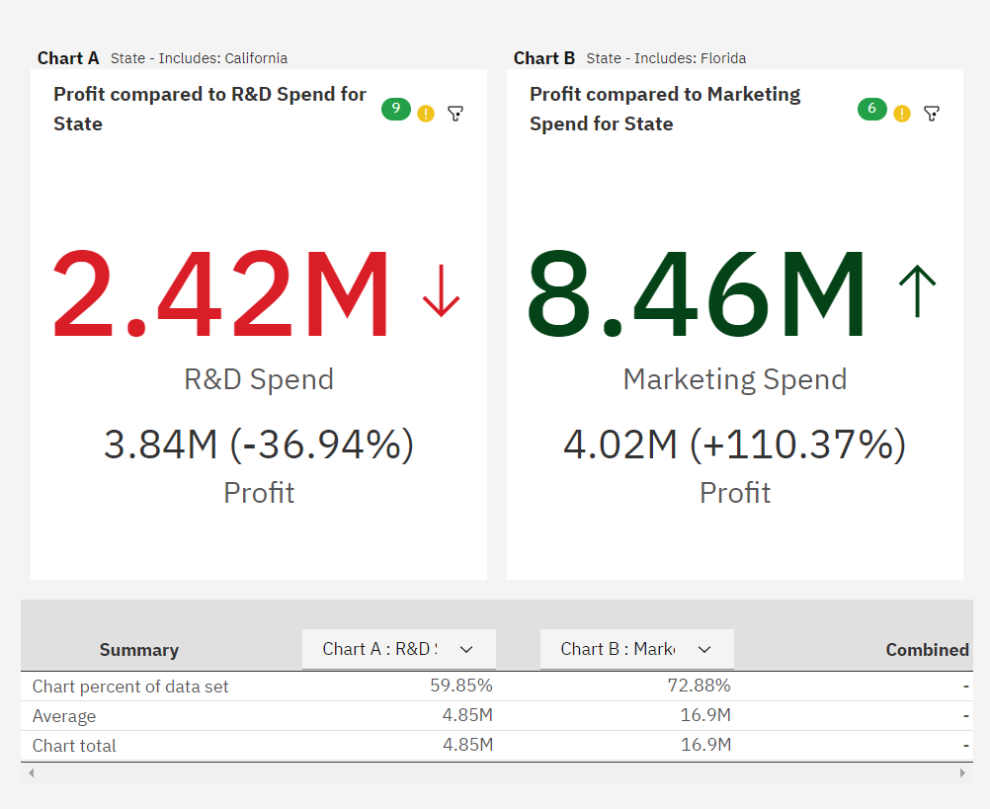

***11.MARKETING SPEND STATE ADMINISTRATION IN COLLISION:***

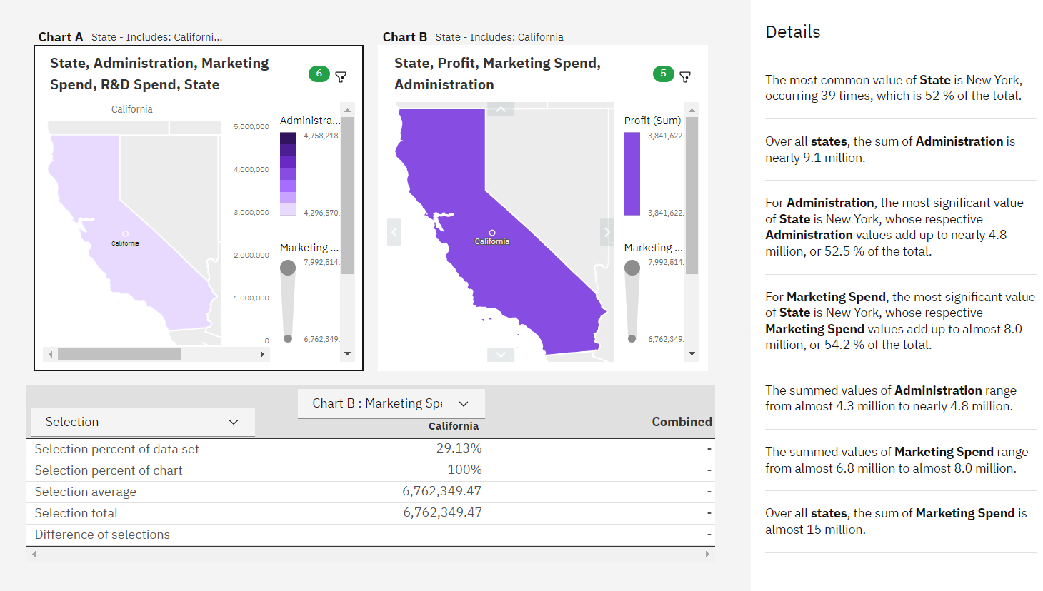

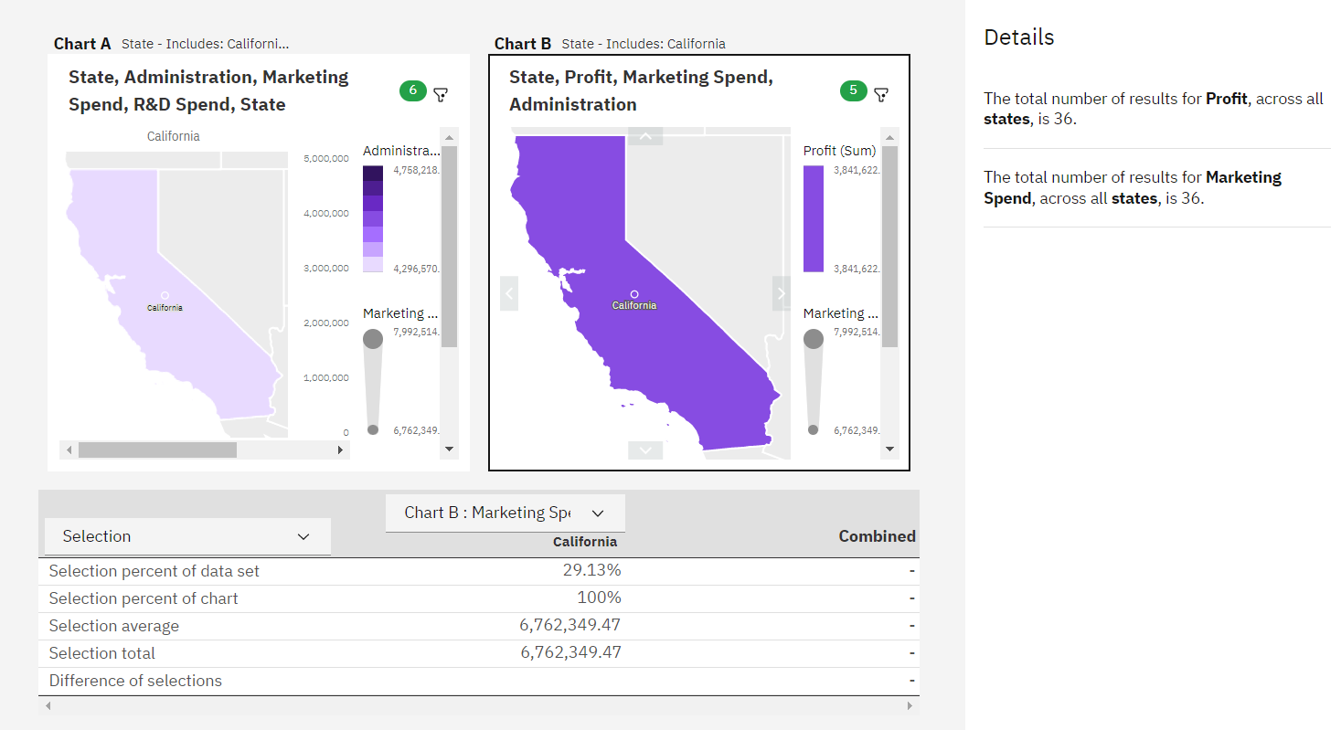

***12.PROFIT TO R&D AND R&D TO MARKETING SPEND:***

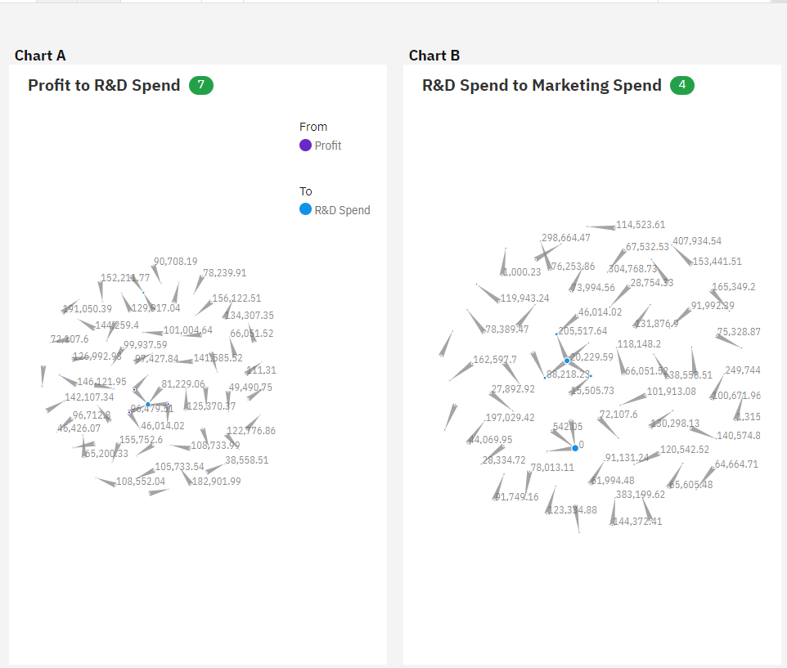

***13.PROFIT ON STATE WISE AND WITH RESPECT TO R&D AND MARKETING:***

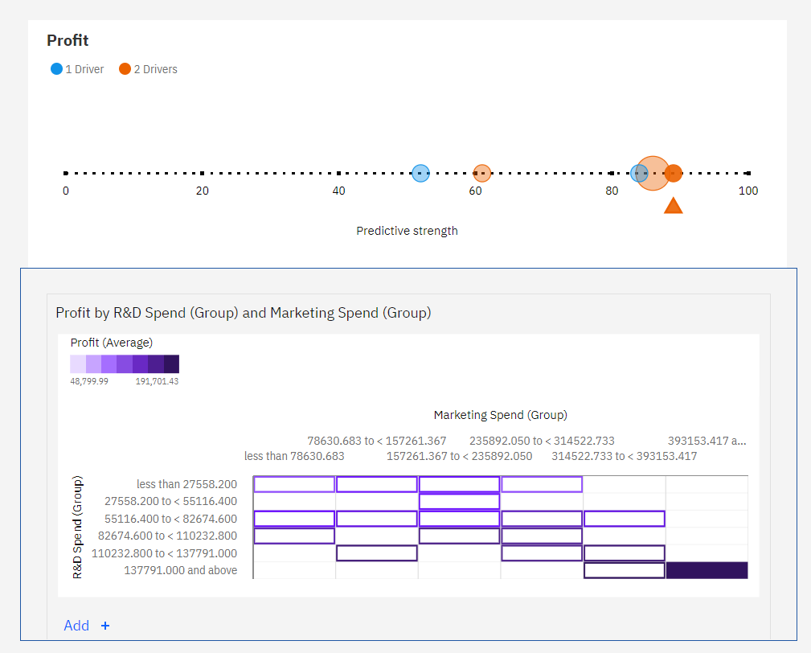

***14.RELATION BETWEEN ADMINISTRATION AND MARKETING SPEND:***

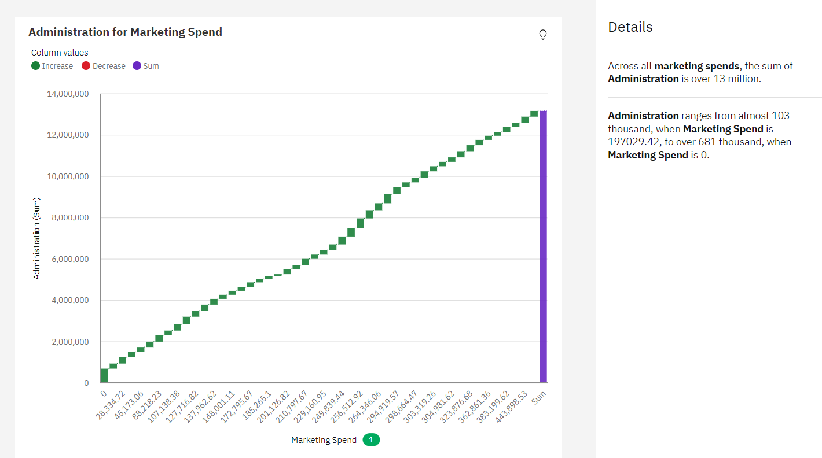

***15.ADMINISTRATION MARKETING AND R&D SECTION WISE:***

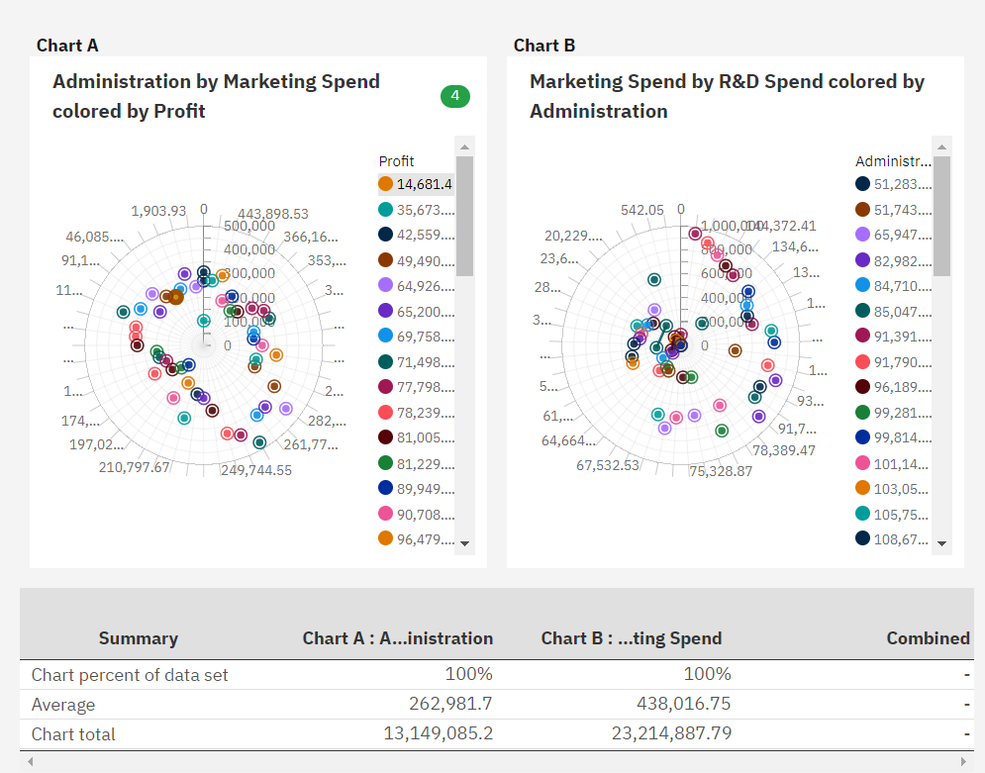

***COGNOS ASSIGNMENT_1 LINK:***

<https://us1.ca.analytics.ibm.com/bi/?perspective=explore&pathRef=.my_folders%2FAssignment_1_Startups>